Question 2: (4 marks)
Write a Graph class in Java that implements an undirected graph, which contains the following members:
- int [][] a; // An adjacency matrix of size nxn.
- int n; // Number of vertices. The vertices are indexed from 0 to n-1.
- char [] v; // The array characters, v[0] is 'A', v[1] is 'B',...
- static int INF = 99; // 99 is considered as infinity value. This variable is used for shortest path algorithm only.
- void setDataFromFile(String filename) throws IOException - get adjacency matrix from file

- void setDataFromArray(int [][] b) - set data from the array b by passing b.length to n, and b[i][j] to a[i][j], i, j = 0,1,...,n-1 .
- void visit(int i) - display the vertex i in character format (i.e. it displays 'A' for i=0, 'B' for i=1,...)
- void dispAdj() - display adjacency matrix.
- void dispDegrees() - calculate and display degrees of all vertices.
- void depthFirst(int k) - depth first traverse from the vertex k.
- boolean isConnected() - check and return true if a graph is connected, return false if it is not connected.
- void breadthFirst(int k) - breadth first traverse from the vertex k.
- void dijkstra(int p, int q) - find and display the shortest path from the vertex p to the vertex q using Dijkstra algorithm.
Note: You can add other data members or methods to the class Graph, or even, you can create other classes if you see they are necessary, but if you are required, you should give a reason for that.

You can download the Main.java to test your application (You can read in the exam paper to know where)

Code to be completed:
/*
You cannot modify or add new statement to the main() function.
However you can disable statements in the main() method if you
cannot complete the corresponding function(s).
Except the main() method, you can modify or add new members to
other class(es) or even you can create new class(es), e.g. you
can delete or modify a given statement(s).
*/
import java.io.*;
import java.util.*;
class MyStack
{LinkedList t;
MyStack() {t = new LinkedList();}
boolean isEmpty() {return(t.isEmpty());}
void push(int k) {}
int pop() {return(-1);}
int viewtop() {return(-1);}
}

class MyQueue
{LinkedList t;
MyQueue() {t = new LinkedList();}
boolean isEmpty() {return(t.isEmpty());}
void enqueue(int k) {}
int dequeue(){return(-1);}
int front(){return(-1);}
}

class Graph
{int [][] a; int n;
char [] v; static int INF = 99; // 99 is considered as infinity value
Graph()
{String s = "ABCDEFGHIJKLMN";
v = s.toCharArray();//v[0]='A', v[1]='B',...
}
void setDataFromFile(String filename) throws IOException
{int i,j;
String s="", s1="";
StringTokenizer t;
RandomAccessFile f;
f = new RandomAccessFile(filename, "r");
s = f.readLine();// The first line contains number of vertices
n = Integer.parseInt(s.trim());
a = new int[n][n];
for(i=0;i<n;i++)
{s = f.readLine();
t = new StringTokenizer(s);
for(j=0;j<n;j++)
{s1 = t.nextToken();
a[i][j]=Integer.parseInt(s1.trim());
}
}

f.close();
}
void setDataFromArray(int [][] b)
{int i,j,t;
n = b.length;
a = new int[n][n];
for(i=0;i<n;i++)
for(j=0;j<n;j++)
a[i][j]=b[i][j];
}
void visit(int i)
{System.out.print(" " + v[i]);
}
void dispAdj() {}
void dispDegrees() {}
void depthFirst(int k) {}
boolean isConnected() {return(false);}
void breadthFirst(int k) {}
void dijkstra(int p, int q) {}
}

//========================================================
class Main
{public static void main(String [] args) throws Exception
{int [][] b = {
{0,1,0,0,1},
{1,0,0,1,1},
{0,0,0,1,0},
{0,1,1,0,0},
{1,1,0,0,0}
};

Graph g =new Graph();

{System.out.println("\n1. Test depth first traverse (2 marks)-2");
System.out.println(" Connected graphs:");
g.setDataFromArray(b);
g.dispAdj();
g.depthFirst(0);
g.setDataFromFile("graph2.txt");
g.dispAdj();
g.depthFirst(0);
System.out.println("\n Non-connected graphs:");
g.setDataFromFile("graph3.txt");
g.dispAdj();
g.depthFirst(0);
}

{
System.out.println("\n2. Calculate degrees of vertices (2 marks)-4");
g.setDataFromFile("graph2.txt");
g.dispAdj();
g.dispDegrees();
}

{System.out.println("\n3. Check connectivity (2 marks)-6");
System.out.println(" Connected graphs:");
g.setDataFromArray(b);
g.dispAdj();
if(g.isConnected())
System.out.println(" The graph above is connected.");
else
System.out.println(" The graph above is not connected.");
System.out.println("\n Non-connected graphs:");
g.setDataFromFile("graph3.txt");
g.dispAdj();
if(g.isConnected())
System.out.println(" The graph above is connected.");
else
System.out.println(" The graph above is not connected.");
}

{System.out.println("\n4. Test breadth first traverse (2 marks)-8");
System.out.println(" Connected graphs:");
g.setDataFromArray(b);
g.dispAdj();
g.breadthFirst(0);
System.out.println("\n Non-connected graphs:");
g.setDataFromFile("graph3.txt");
g.dispAdj();
g.breadthFirst(0);
}

{System.out.println("\n5. Test Dijkstra shortest path algorithm (2 marks)-10");
g.setDataFromFile("graph4.txt");
g.dispAdj();
g.dijkstra(0,5); // Shortest path from vertex 1 to vertex 6
}

System.out.println();
}
}

Adjacency matrixes:

graph1.txt

5
A
C
E
B
D
0 1 0 0 1
1 0 0 1 1
0 0 0 1 0
0 1 1 0 0
1 1 0 0 0

graph2.txt
10
0 1 0 1 1 0 0 1 1 0
1 0 0 1 1 0 0 0 0 0
0 0 0 1 0 0 0 0 0 0
1 1 1 0 0 1 0 0 0 0
1 1 0 0 0 1 1 1 0 0
0 0 0 1 1 0 0 0 0 0
0 0 0 0 1 0 0 0 0 1
1 0 0 0 1 0 0 0 1 1
1 0 0 0 0 0 0 1 0 1
0 0 0 0 0 0 1 1 1 0

C
B
D
E
F
A
G
H
J
I

 | A | B | C | D | E | F | G | H | I | J
A | 0 | 1 | 0 | 1 | 1 | 0 | 0 | 1 | 1 | 0
B | 1 | 0 | 0 | 1 | 1 | 0 | 0 | 0 | 0 | 0
C | 0 | 0 | 0 | 1 | 0 | 0 | 0 | 0 | 0 | 0
D | 1 | 1 | 1 | 0 | 0 | 1 | 0 | 0 | 0 | 0
E | 1 | 1 | 0 | 0 | 0 | 1 | 1 | 1 | 0 | 0
F | 0 | 0 | 0 | 1 | 1 | 0 | 0 | 0 | 0 | 0
G | 0 | 0 | 0 | 0 | 1 | 0 | 0 | 0 | 0 | 1
H | 1 | 0 | 0 | 0 | 1 | 0 | 0 | 0 | 1 | 1
I | 1 | 0 | 0 | 0 | 0 | 0 | 0 | 1 | 0 | 1
J | 0 | 0 | 0 | 0 | 0 | 0 | 1 | 1 | 1 | 0

graph3.txt
14
A
C
E
B
D
I
H
F
G
L
J
K
N
M
0 1 0 0 1 0 0 0 0 0 0 0 0 0
1 0 0 1 1 0 0 0 0 0 0 0 0 0
0 0 0 1 0 0 0 0 0 0 0 0 0 0
0 1 1 0 0 0 0 0 0 0 0 0 0 0
1 1 0 0 0 0 0 0 0 0 0 0 0 0
0 0 0 0 0 0 1 1 1 0 0 0 0 0
0 0 0 0 0 1 0 1 0 0 0 0 0 0
0 0 0 0 0 1 1 0 0 0 0 0 0 0
0 0 0 0 0 1 0 0 0 0 0 0 0 0
0 0 0 0 0 0 0 0 0 0 0 0 1 0
0 0 0 0 0 0 0 0 0 0 0 1 0 0
0 0 0 0 0 0 0 0 0 0 1 0 1 0
0 0 0 0 0 0 0 0 0 1 0 1 0 1
0 0 0 0 0 0 0 0 0 0 0 0 1 0

Graph4.txt
7
0 10 99 99 99 99 8
99 0 2 10 25 80 99
30 99 0 8 3 20 99
20 99 99 0 99 5 10
99 99 99 4 0 99 99
8 99 99 99 99 0 5
8 99 99 99 99 99 0

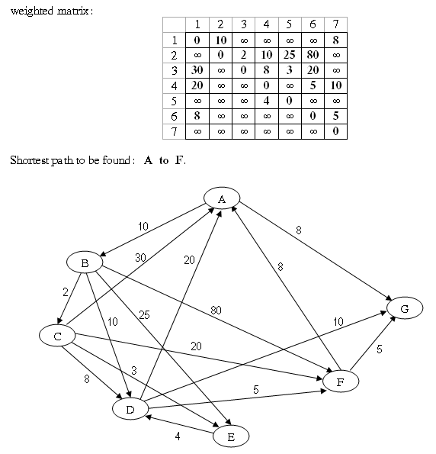

Output:

